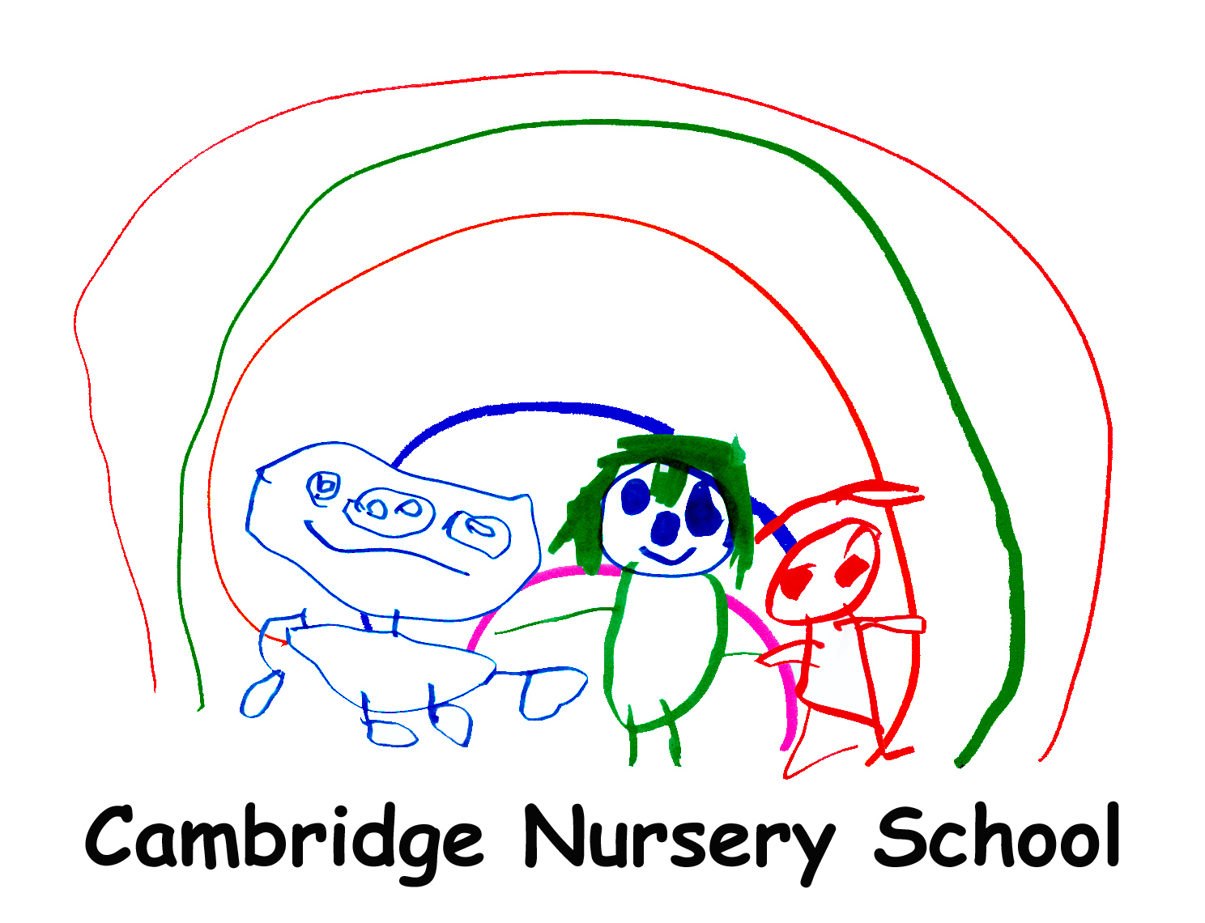
Cambridge Road
Cambridge Nursery School
Bootle
Merseyside
L20 9LQ
Tel: 0151 282 5467
Fax: 0151 291 5440 Headteacher: Debbie Clark

Email: admin.cambridgecc@schools.sefton.gov.uk
Website: www.cambridgenurseryschool.com
‘Enhancing the lives of young children and their families’

Dear applicant,
Thank you for your interest in applying for the post of Headteacher at Cambridge Nursery School.

Our current, longstanding and very successful Headteacher will take early retirement at the end of the summer term and we are keen to recruit someone who is as committed to, and as passionate about the school as she has been.

Cambridge Nursery School was established in 1974 and has been through many changes, one being one of the first phase one children’s centres and a flagship for high quality early education. Sadly, in 2018 the local authority closed the children’s centres, but we have however continued with the commitment that we support the whole family, and our mission statement is ‘Enhancing the lives of our children and families’

Cambridge is a resourced nursery school traditionally having 4 resourced places funded for children who have lifelong and complex needs. We are a positive and happy school community and we are proud of our welcoming and family atmosphere. We recognise and celebrate that all children come from diverse backgrounds and that they all deserve the best start in life.

The Nursery school has achieved recognition for our practice and have received “School of Sanctuary” and “Trauma and Attachment Sensitive School” awards among other accolades.To quote our Bronze award report for being a Trauma and Attachment Sensitive School, “Cambridge Nursery school has developed a culture of compassion and nurture. This as you know plays a pivotal role in getting children in to a state of learning readiness.”
Staff at our school are dedicated to pursuing the best outcomes for the children that they teach and also ensuring they are happy at school.

The governing body is committed to supporting the continuous professional development for all staff and as a result our school has been part of many research projects benefitting both the children and staff.

We are looking for someone who will understand the needs of our children and their families and will put this at the centre of everything they undertake.
We welcome your interest in this role and look forward to receiving your application. It is a really exciting opportunity to lead an ambitious school, build on already firm foundations, and also bring a fresh perspective to drive our school forwards.

I would encourage candidates to visit the school to appreciate the nurturing environment and experience the wonderful ethos established at the school.

Kind regards

Ms Julie Cliff (BA Hons)
Chair of the Governors

Please note in line with keeping Children Safe in Education 2023, an online search may be carried out as part of our due diligence on short listed candidate.

References, one of which should be from your Chair of Governors / Head teacher will be sought, as soon as applicants are shortlisted. All applications are references will of course be treated in strictest confidence.

