SEFTON METROPOLITAN BOROUGH COUNCIL

FORMAT JOB DESCRIPTION

Department: Economic Growth and Housing Location: Sefton @ Work

Division: Investment & Employment Post No: TBC

Section: Sefton@Work JE Number: TBC

Post: Client Adviser Grade: TBC

Responsible To:
Senior Adviser (Restart)

Responsible For:
N/A

JOB PURPOSE
To provide advice, guidance and practical support to our clients who have been out of work for at least 12 months, to find sustainable employment through the new DWP Restart Programme. To deliver the service in line with programme requirements while achieving contractual related targets in accordance with our ethos and Matrix accreditation.

CORE DUTIES (F & G Grades)

- To raise awareness of the service and undertake engagement activities to generate new referrals to allow access to our programmes at various venues across the borough.

- To conduct quality controlled individual information, advice and guidance in both individual and group sessions with residents via a range of blended delivery methods (In-Person, Telephone and Virtual) and provide a high level of customer service and support.

- To conduct general employability assessments designed to draw out any potential barriers and measure distance travelled.

- To manage a caseload of clients accessing the service who have low level needs and minor barriers to progression/employment.

- To provide services to residents that are tailored to take into account any employability barriers they face, their skills and qualifications and their future potential.

- To conduct job search sessions and support the application process e.g. completing online applications, registering on websites, sending CV’s to employers etc.

- To create quality CV’s and covering letters/emails/web profiles for clients.

- To develop general actions plans in partnership with clients to identify SMART actions to aide progression.

- To undertake work with the Employer Liaison Team, employers and training providers in order to identify and match to employment and training opportunities suitable for residents.

MAIN DUTIES (continued)

- To contribute to the team and achieve individual contractual targets as set out by your Line Manager.

- To network and work in collaboration within SMBC and other partner organisations relevant to the service (e.g. Jobcentre Plus, Career Connect, etc).

- To keep up to date with developments in education, training, employment and regeneration, both locally and nationally.

- To support recruitment campaigns in conjunction with management and undertake associated activities that maximise jobs for local people, including delivery of pre-recruitment training.

- To maintain robust and accurate client records and evidence outcomes in line with programme guidance and compliance.

- To work as part of a team to develop the Sefton@Work service in line with the Matrix Quality Standard and Customer Service Excellence, leading to a recognised achievement.

- To contribute to publicity and awareness raising events as directed by management.

- Actively promote the provision of equality of opportunity within the initiative and promote non-discriminatory practices in all aspects of the work undertaken.

- To participate in training, coaching and development programmes as required and use all relevant learning opportunities to improve personal skills to enhance the effectiveness and efficiency of service delivery.

ADDITIONAL DUTIES (Professional/G Grade)

- To manage a large caseload of clients accessing the service who have high level complex needs and multiple barriers to progression/employment.

- To conduct quality controlled individual information, advice and guidance to provide in-depth advice, guidance and support to those with complex barriers and needs (e.g. Ex-Offenders, MAPPA, ESOL, Substance Misuse, Leaving Care) linking in with specialist provision where appropriate.

- To develop in-depth tailored action plans that identify clear progression routes for all clients including those with complex needs, setting goals and SMART actions to overcome barriers and move towards or into sustainable opportunities.

- To give advice and administer (if appropriate) testing for clients regarding any special needs (such as literacy or numeracy) and conduct complex employability assessments designed to draw out barriers and measure distance travelled.

- To network and work in collaboration within SMBC and outside specialist agencies and organisations relevant to the service and needs of the clients to help ensure the barriers facing individuals can be addressed through joint action plan and advocacy.

- To prepare and deliver group employability sessions, both within the Sefton@Work offices(s) and on an outreach basis throughout the borough, to enable individuals to achieve their career goals.

PROGRESSION CRITERIA

- Scale G requires a professional sector specific qualification at a minimum of Level 4 or equivalent e.g. NVQ Level 4 in Information, Advice & Guidance, Career Development etc.
- An applicant with significant experience (3+ years) of working within the sector or in a role that provides advice & guidance and/or those working towards L4 or above qualification may also be considered on Scale G if can evidence work history through references
- Scale F will not require any professional sector specific qualification, but candidates must be willing to undertake a minimum of IEP Level 2 and move on to a L4 in Employability Professionals qualification which will act as the route to move to grade G

ORGANISATION CHART

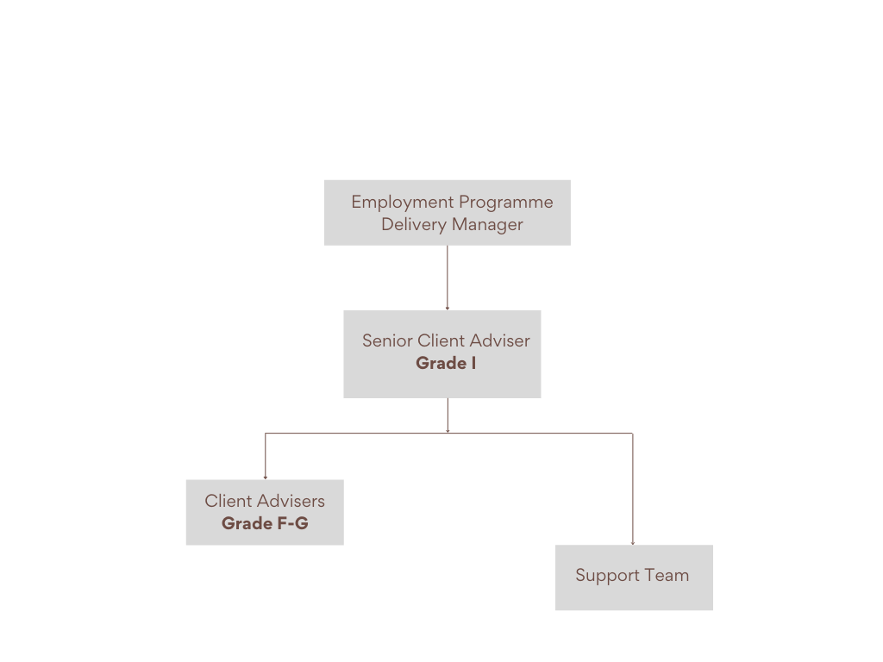

SPECIAL CONDITIONS (if applicable)

This post is designated as an authorised casual car user.

The post you are applying for is exempt from the Rehabilitation of Offenders Act 1974 and therefore you are required to declare any convictions, cautions, reprimands and final warnings that are not ‘protected’ (i.e. filtered out) as defined by the Rehabilitation of Offenders Act 1974 (Exceptions) Order 1975 (Amendment) (England and Wales) Order 2013.

For further information, please refer to DBS filtering guidance at www.gov.uk/dbs.

The post you are applying for requires access to the Public Service Network (PSN) and requires compliance with the HMG Baseline Personnel Security Standard. The post also requires a DBS Basic Disclosure as you will be dealing with sensitive data.

Since confidential information is involved with the duties of this post, the postholder will be required to exercise discretion at all times and to observe relevant codes of practice and legislation in relation to data protection and personal information.

The person appointed will be expected to work in a variety of settings and facilities within the community and be willing to work flexible hours. Saturday working may be required.

The exact nature of the duties described above is subject to periodic review and is liable to change.

Sefton @ Work is funded externally. The post holder may work on a Project funded through one or more funding streams.

The post is customer facing therefore you must have the ability to fulfil all spoken aspects of the role with confidence through the medium of English.

GENERAL:

This job description is a representative document. Other reasonably similar duties may be allocated from time to time commensurate with the general character of the post and its grading.

All staff have a duty to take care of their own health and safety and that of others who may be affected by your actions at work. Staff must co-operate with employers and co-workers to help everyone meet their legal requirements.

The Authority has an approved equality policy in employment and copies are available to all employees. The post holder will be expected to comply with, observe and promote the equality policies of the Council.

Note: Where the postholder is disabled, every effort will be made to support all necessary aids, adaptations or equipment to allow them to carry out all the duties of the job.

Prepared by: Name: Linda Patterson

Designation: Manager Sefton @ Work

Date: 15/12/2021

PERSON SPECIFICATION
DEPARTMENT |  | Investment & Employment | DIVISION |  | Regeneration & Housing  Sefton@Work
POST |  | Client Adviser (Restart) | GRADE |  | F – G (Career Graded)
QUALIFICATIONS, PERSONAL SKILLS & ATTRIBUTES REQUIRED |  |  | NOT REQUIRED (NR) ESSENTIAL (E) OR DESIRABLE (D)
 |  |  | GRADE F | GRADE G |  | HOW ASSESSED
1. | Holds a minimum of Level 4 qualification in Information, Advice & Guidance/ Employability Practitioner or equivalent OR a minimum of 3 years relevant professional work experience in a similar role. |  | NR | E |  | AF/I/C
2. | Willing to work towards and achieve IEP Level 2 for Employability Professionals and move towards a Level 4. |  | E | D |  | AF/I
3 | Recent experience of working in the Welfare to Work, recruitment or employment & learning sector. |  | D | E |  | AF/I
4 | Recent experience of successfully engaging with individuals to recruit them onto employment programmes. |  | D | E |  | AF/I/P
5 | Experience of working towards and being accountable for the achievement of contractual individual and team targets. |  | E | E |  | AF/I
6 | Experience of delivering services in an outreach setting to the public, specifically in JCP and community settings. |  | NR | E |  | AF/I
7 | Knowledge of barriers facing individuals excluded from the labour market. |  | D | E |  | AF/I
8 | Experience of maintaining accurate client records and auditable evidence to ensure all outcomes are compliant and claimable. |  | D | E |  | AF/I
9 | Knowledge of training, learning and employment opportunities available in Sefton and the wider LCR area. |  | D | E |  | AF/I
10 | Experience of using a range of communication methods to engage with clients inc. telephone and virtual conferencing calls to deliver advice and employability sessions. |  | D | E |  | AF/I/P
11 | IT literate with knowledge of a range of software packages inc. Microsoft Word, Excel, Outlook, Teams, Internet and Case Management Systems. |  | E | E |  | AF/I
12 | Ability to work unsupervised and use own initiative. |  | D | E |  | AF/I
13 | Excellent communication skills with the ability to engage with individuals at a range of levels and organisations from various sectors. |  | E | E |  | AF/I/P
14 | Excellent organisation skills with the ability to prioritise workload including a caseload of clients. |  | E | E |  | AF/I
15 | Knowledge of general recruitment services/initiatives offered by relevant local partner agencies. |  | D | E |  | AF/I
16 | Knowledge of and experience of working in partnership with specialist support agencies that provide practical help to those with complex needs (MAPPA, ESOL, Substance Misuse, Leaving Care, Youth Offending Team etc). |  | NR | E |  | AF/I
17 | Ability to respond to requests quickly and efficiently. |  | E | E |  | AF/I
18 | Ability to work well under pressure and meet deadlines whist maintaining a high standard of work. |  | E | E |  | AF/I
19 | Knowledge of marketing and publicity and how to use this to raise awareness and promote our services in the community. |  | D | D |  | AF/P
20 | Empathy to low income areas. |  | E | E |  | AF
21 | Commitment to equal opportunities. |  | E | E |  | AF
22 | Willingness to travel across the borough of Sefton to promote and deliver services. |  | E | E |  | AF/I
23 | Willingness to work outside normal working hours when required, including evening and weekends. |  | E | E |  | AF/I

KEY | AF – Application Form | C – Certificate | I – Interview | P - Presentation

