Person specification
Post title | Marketing & Communication Coordinator | Scale | F

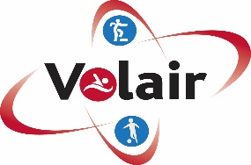

* * * This post is exempt from the provisions of the Rehabilitation of Offenders Act – applicants must disclose all criminal convictions including those which are ‘spent’, in addition to any cautions and bindover orders received in the last 12 months * * *

Criteria | Essential requirements | * M.O.A
Skills, knowledge, experience etc
1 | Excellent administrative, organisational and communication skills | A/I
2 | Excellent attention to detail and accuracy. | A/I
3 | Excellent computer literacy including Microsoft Office skills | A/I
4 | Confident in learning new software skills quickly | A/I
5 | Experience and knowledge of communicating with a wide range of audiences | A/I
6 | Proven track record in social media management and content creation | A/I
7 | Experience and knowledge of managing websites and graphic design (Adobe Creative Suite, Cavna etc.) | A/I
8 | Excellent team player | A/I
9 | Understanding or retention techniques | A/I

Qualifications
10 | Marketing relevant degree (Desirable) or equivalent educational attainment | A/I
Health and safety
11 | Ability to use equipment as instructed and trained | A/I
12 | Ability to inform management of any health and safety issues which could place individuals in danger | A/I
13 | Ability to operate and ensure customers safety at all times | A/I
Personal attributes and circumstances
14 | Commitment to continual professional development | A/I
15 | Ability to work evening, weekends and Bank Holidays as required. | A/I

*Method of assessment (*M.O.A)
A = Application form
C = Certificate
E = Exercise
I = Interview
P = Presentation
T = Test
AC = Assessment centre

Date | Approved by authorised manager | Designation

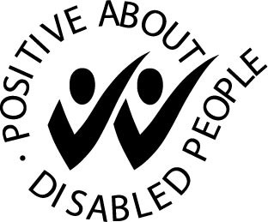
We have a positive attitude to the employment of disabled people and guarantee an interview to those who meet all the necessary criteria of the person specification.

