SEFTON METROPOLITAN BOROUGH COUNCIL

JOB DESCRIPTION

Department: Strategic Support – Performance & Business Intelligence

Location: Magdalen House

Post: Senior Data Analyst

Grade: Grade I (JE Ref: A4969)

Accountable to: Performance & Business Intelligence Lead

Accountable for: Advising and supporting others to perform in-depth data analysis, and to produce detailed and concise written performance reports, applying they key types of data analytics to get the greatest insight from the Council’s data and for it to inform strategic decisions.

JOB PURPOSE

Performance and Business Intelligence functions, providing information, intelligence, and insight in the form of data analysis, data visualizations, and written reports, to support the Council’s strategic planning, commissioning, and performance management processes.

MAIN DUTIES

- Supervise others across the team in producing and delivering accurate management information and business intelligence, overseeing the gathering, analysing, and imparting of timely and accurate data, information, intelligence, and insight, responding swiftly and efficiently to both planned and ad-hoc information requests from internal Council departments, key partner agencies and external organisations, and adjusting priorities to meet changing organisational needs.

- Lead on data analysis projects, the interpretation and reporting of complex data using the most appropriate analytical techniques, supporting others, and developing the capability and capacity within the Council’s Performance and Business Intelligence Team.

- Lead and support others across the team to collate, prepare, validate, transform, and integrate large quantitative data sets gathered from multiple sources, including statistical data from trusted external sources and structured data from Council systems using a range of tools including Azure Data Factory, MS SQL Server Management Studio (SSMS), and MS Excel.

- Lead and support others across the team to perform in-depth data analytics to measure key performance indicators, identify trends and patterns, for benchmarking, forecasting, and deriving value out of the Council’s data at an enterprise scale, using MS Excel, Business Objects, MS SQL Power BI, and a range of quantitative data analysis techniques such as descriptive, diagnostic, inferential, predictive, prescriptive, regression and correlation.

- Ensure timely and accurate reporting to stakeholders on agreed areas of work, including departmental and corporate performance reports. Prepare and present data, information and insight in written reports and visually rich, dynamic, and interactive dashboards using MS Power BI or MS Excel.

- Lead and support others across the team in compiling statutory and non-statutory returns, including collecting, modelling, cleansing, loading, and submitting data in XML or CSV format and leading the response to validation checks and correcting data errors to ensure the accuracy, consistency, and integrity of data submitted.

- Conduct research activities, collating information using multiple research methods, analysing data, and creating professional written reports with clear and meaningful content, brevity, credible evidence sources and recommendations.

- Manage complex data projects, leading others the process to complete deliverables successfully to scope, within a set timeframe and budget, including preparing project documentation, planning, tracking, and communication.

- Assist in the development and maintenance of Council datasets, including monitoring data quality, and contribute to the process of fixing or removing corrupted, incorrectly formatted, duplicate, or incomplete data within a dataset.

- Present accurate data, information, intelligence, and insight to politicians, senior leaders, managers and workstream leads, providing support so that they can coherently interpret and understand data and identify opportunities to maximise strategic benefits and service improvement.

- Contribute towards and support others across the Council to develop performance management and reporting frameworks, to ensure that service areas have effective measures in place and to help drive service improvement and value for money.

- Explore and implement ways of innovatively incorporating automation, machine learning and AI into data analysis and reporting.

ORGANISATION CHART

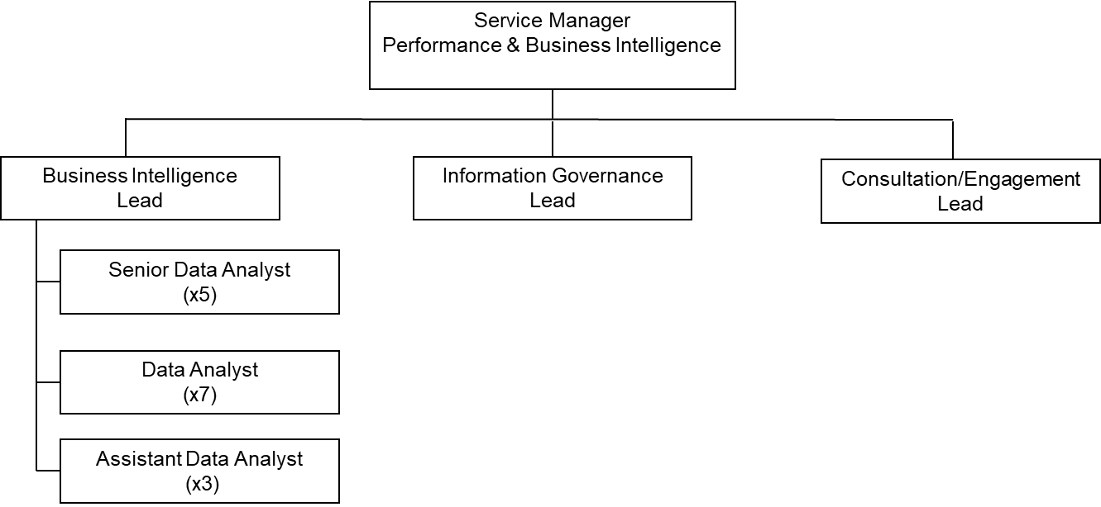

SPECIAL CONDITIONS

See attached chart

QUALIFICATIONS AND EXPERIENCE.

See attached Person Specification

SPECIAL CONDITIONS (if applicable)

The post holder will deal with data of a confidential and sensitive nature. They must maintain confidentiality and the trust of the data providers always.

The post holder will be the subject of Government vetting including BPSS (Baseline Personnel Security Standard), which is the required level of screening for any individuals working with or on behalf of a government department that allows the holder to access confidential information.

Occasional out-of-hours work may be required.

GENERAL:

The post holder will be expected to comply with, observe and promote the Equal Opportunities policy of the Council.

All staff are responsible for the implementation of the Health and Safety Policy so far as it affects them, their colleagues and others who may be affected by their work. The post holder is also expected to monitor the effectiveness of the health and safety arrangements and systems and to promote appropriate improvements where necessary.

This job description is a representative document. Other reasonably similar duties may be allocated from time to time, commensurate with the general character of the post and its grading.

Prepared by:
Name: Wayne Leatherbarrow
Designation: Service Manager – Performance & Business Intelligence
Date: October 2022
PERSON SPECIFICATION

Post: Senior Data Analyst | Department: Performance & Business Intelligence

Personal Attributes Required | Essential (E) or  Desirable (D) | Method of Assessment
Qualifications  Educated to degree level in data science or hold an equivalent professional qualification or equivalent experience in information management or statistical analytics | E | AF/C
Experience
Leading, and supporting others to produce and deliver timely and accurate business intelligence in a senior role.  - Extensive knowledge of Local Authority Children’s Services, Education, Public Health, Communities or Adult Social Care services in the context of data analysis.  - Analysis, interpretation, and reporting of complex data using appropriate advanced analytical techniques and statistics.  - Advanced understanding and experience in the use of the Microsoft Data Warehouse technology stack including T-SQL, Azure SQL Database, Azure Data Factory, and Microsoft Power BI.  - Compilation, submission, and validation of statutory and non-statutory data returns.  - Conducting research and needs assessments and creating professional written reports.  - Managing complex data cleansing, data analysis, data visualisation or machine learning projects.  - Development of partnership working and engagement across organisations and sectors.  - Incorporating automation, machine learning and AI into data analysis and reporting. | E  E  E  E  E  E  D  D  D | AF/I  AF/I  AF/T/I  AF/I  AF/I  AF/T/I  AF  AF  AF

Ability, Skills & Knowledge
- Excellent IT skills and expert working knowledge of T-SQL, Power BI and Excel for data collating, analysis, and reporting.  - Excellent communication skills; written and verbal; able to communicate effectively at all levels within the organisation and with external bodies and to present complex information to a variety of audiences.  - Highly numerate and literate with exceptional attention to detail and accuracy.  - Ability to operate effectively with a high volume and sensitive workload, delivering to expectation and deadlines, responding, and reacting positively to situations when working under pressure.  - Knowledge of the Data Protection Act and how to apply it in respect of data processing.  - Ability to collaborate effectively and work flexibly within and across different services and topic areas  - Programme and project management skills.  - Knowledge of automation, machine learning and AI in data analysis and reporting. | E  E  E  E  E  E  D  D | AF/I  AF/T/I  AF/T/I  AF/I  AF/I  AF/I  AF  AF
Personal Style and Behaviour
- Act as a role model to peers and demonstrate leadership.  - An inclusive team worker, able to work with others and in a collaborative manner with respect and consideration for the skills of others.  - Constructively challenge inappropriate behaviour and use of information when necessary.  - Self-motivated, proactive, optimistic, and enthusiastic with the ability to respond to challenge and not to be discouraged. | E  E  E  D | AF/I  AF/I  AF/I  AF
Other/Special Requirements  Evident commitment to personal continued professional development. | D | AF/I
Assessment Methods Key:

AF – Application Form C – Certificates
I – Interview T - Test

