27th February 2025

Dear Applicant

**Part-time Receptionist**

Welcome to Range High School and thank you for taking the time to consider coming to work at our popular and thriving school.

The Governors wish to appoint a part-time Receptionist to work in our busy reception area. The successful candidate will work term-time only for 14 hours per week - between 08:00 to 16:00 on a Thursday and Friday.

Uniquely set next to nationally known nature reserves in an area of outstanding beauty and the impressive coastline of the Irish Sea, with good commuter links, Range High is an 11-18 community school in Formby. The school has a reputation for high educational standards, and a caring ethos which focuses on the development of the individual. The 1100 pupils on roll (including the 6th Form) are drawn from both the immediate and surrounding areas.

The school is forward looking with a good track record of achievement and is proud to have been awarded ‘Good’ by Ofsted following their inspection in March 2022. We are ambitious and the Governors, Senior Leadership and Staff endeavour to provide the best educational opportunities to all of the students regardless of their academic ability. The school is an exciting and vibrant place to work and we would encourage you to apply for this post to test this out for yourself!

Candidates are asked to complete the application form, available from the school website [www.range.sefton.sch.uk](http://www.range.sefton.sch.uk) and to return it by the deadline of **16:00 on** **Monday 10 March 2025**. Completed applications must be returned to school by either post or e-mail ([sld@range.sefton.sch.uk](mailto:sld@range.sefton.sch.uk) ).

For an informal chat regarding this post, please contact Mrs Stephanie Donbavand, Operations Director on 01704 879315 or by email on [sld@range.sefton.sch.uk](mailto:sld@range.sefton.sch.uk) .

**If you have not heard from school by Thursday 13th March 2025 you should assume that your application has been unsuccessful.**

Yours faithfully,

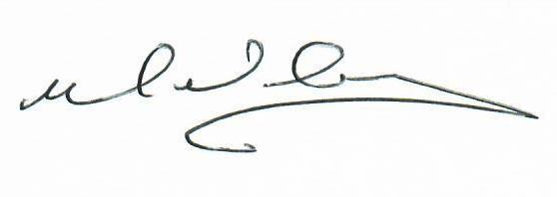

Mike McGarry

**Headteacher**