March 2025

Our Ref CH/DO’C

Dear Colleague

Thank you for enquiring about the vacancy for the post of Teacher of Science at Litherland High School.

I attach the following:

Covering letter (please see below)

An application form

Equal opportunities monitoring form

Further information about the School, including a link to our OfSTED report, can be found at *www.litherlandhigh.com*

Please complete the application form and return it, together **with a separate cover letter of application, by 12** **noon on Friday 2nd May.**

In your cover letter, please indicate:

Your previous experience which you consider to be relevant to the post.

How your skill set ensures you will be successful in this post.

How you could contribute to the school becoming outstanding.

I look forward to receiving your application. Once again, thank you for your interest.

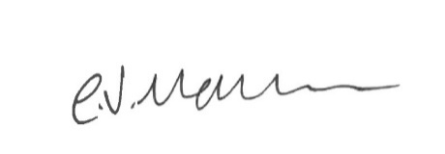Yours sincerely

Mrs C. Hallwood

Principal