JOB DESCRIPTION

Department: Corporate Personnel Location: Ainsdale/Hybrid

Section: Workforce Learning and Development

Post Description: Learning and Development Business Partner (Management Information)

Post No: TBC Grade: Grade I JE No. 2497

Reporting to: Senior Learning and Organisational Development Business Partner

Responsible for: N/A

Job Purpose:

To primarily work with the ICT Client Team to design, develop and deliver a range of training programmes that support the implementation of appropriate Management Information (MI) and IT solutions that will assist change across a range of services. The main focus of this role will be to deliver IT systems training for Children’s and Adult Social Care.

To develop and sustain a learning strategy for other identified areas that equips managers and employees with appropriate skills, knowledge and attitudes relevant to their job roles.

Main Duties:

- To develop and deliver a full range of ICT Learning and Development Programmes, including, Liquid Logic (adults, children’s and early help), Controcc, Capita One, iCasework and Child View.

- To keep up to date with new and existing software improvements and amending training materials as required.

- To oversee the functioning of ICT equipment within the building and when required to provide bespoke training according to the needs of individuals, groups and the wider workforce on the use and application of a wide range of ICT equipment.

- To undertake all the processes involved in the training cycle i.e. design, develop and deliver a range of learning and development events.

- To engage with key stakeholders to design training programmes that are fit for purpose and that meet the needs of the business.

- To conduct evaluations and evidence impact to determine the effectiveness of learning and whether it has achieved its intended outcomes.

- To produce reports for the Corporate Workforce Board and Directors as requested.

- To maintain links with managers, staff and colleagues and provide advice and guidance in ICT issues as required.

- To manage agreed financial budgets for specialist activities and ensure that resources are used in the most efficient manner. This includes commissioning of external training activities.

- To ensure compliance with GDPR when working with a range of Information Systems. This includes the confidentiality, security, and quality of service user and client records.

- To use the Learner Management System (Me Learning) to ensure all course information and bookings are accurately recorded.

- To provide advice, guidance and information that supports cultural change and the development of policies and procedures across the council.

- A willingness to learn new subjects and to deliver training across a broad range of areas if required. Subjects to be determined by the Workforce and Learning Service Manager.

Organisation Chart

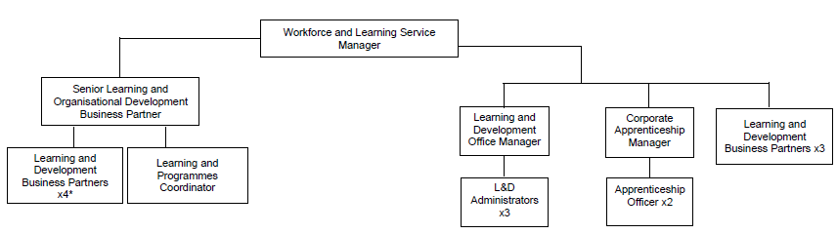
*This post.

Special Conditions

The Authority has approved a policy on Equal Opportunities in Employment and copies are freely available to all employees.

All staff are responsible for the implementation of the Health and Safety Policy so far as it affects them, their colleagues and others who may be affected by their work. The post holder is also expected to monitor the effectiveness of the health and safety arrangements and systems to ensure that appropriate improvements are made where necessary.

General

This job description is a representative document. Other reasonably similar duties may be allocated from time to time commensurate with the general character of the post and it’s grading.

All staff are responsible for the implementation of the Health and Safety Policy as far as it affects them, colleagues and others who may be affected by their work. The post holder is also expected to monitor the effectiveness of the health and safety arrangements and systems to ensure appropriate improvements are made where necessary.

The Authority has an approved equality policy in employment and copies are freely available to all employees. The post holder will be expected to comply, observe and promote the equality policies of the Council.

Since confidential information is involved with the duties of this post, the post holder will be required to exercise discretion at all times and to observe relevant codes of practice and legislation in relation to data protection and personal information.

Undertake, and participate in training, coaching and development activities, as appropriate.

Note: Where the post-holder is disabled, every effort will be made to support all necessary aids, adaptations or equipment to allow them to carry out all the duties of the job.

Prepared by

Name: Michael Mainwaring

Designation: Workforce Learning and Development Manager

Date: April 2025

