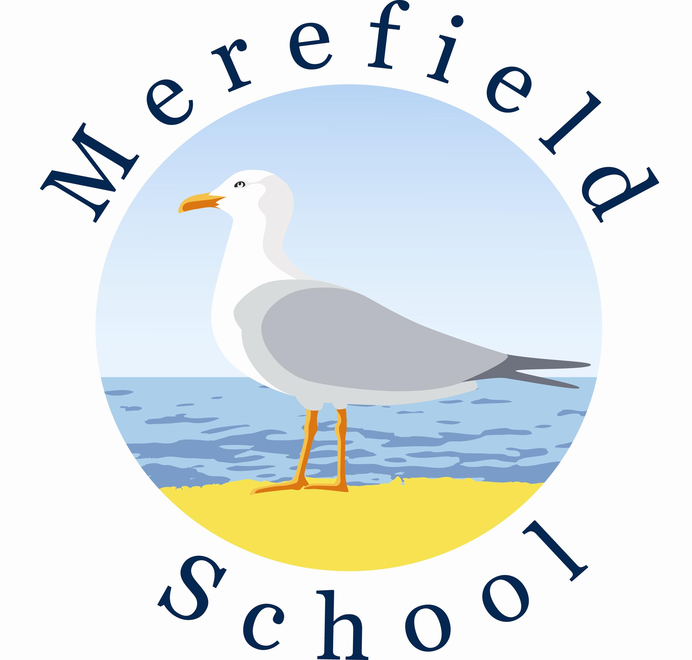
Merefield School

Post Title: | Teacher - Permanent
Grade: | MPS – UPS + 1 SEN point
Accountable to: | Headteacher and the Governing Body
Line Manager: | Deputy Headteacher

Job Description Class Teacher

Merefield School is committed to safeguarding and promoting the welfare of children and young people and expects all staff and volunteers to share this commitment
Job Purpose | To teach all subjects across the all ages and ability ranges including Primary, Secondary and Sixth Form as applicable.  To ensure students make outstanding progress based on their individual starting points, aspirations and academic goals.  To coordinate a subject across the school, subject to be negotiated based n personal strengths and experience.
Key Tasks

Class teacher | - To use knowledge and skills to teach pupils and students across within a class/ Key Stage.  - To plan and deliver a range of ASDAN awards and qualifications.  - To use technology to support engaging and exciting teaching.  - To plan lessons which match the full range of learners’ needs.  - To use regular, thorough and accurate assessment that informs learners how to improve that will contribute to student progress.  - To plan and deliver well informed and engaging lessons according to the Merefield School Teaching and Learning policy.  - To devise, implement, review and monitor personalise learning intentions for class pupils and to communicate contents to parents.  - To be responsible for the health and safety of students who are in your care.  - To manage the learning of students in a secure and friendly environment in which they can thrive.  - To use data to monitor and evidence student progress.  - To provide data on the progress of students taught.  - To ensure all students assigned make at least the expected level of progress due to good teaching.  - To motivate, support and challenge students to ensure that they have good attitudes to learning.  - To contribute to extra-curricular provision.  - To maintain equipment to ensure it is in working order for lessons / shows.  - To actively support the ethos of the school, ‘where pupils and students can reach their full potential’.  - To demonstrate professional characteristics at all times with all stakeholders, colleagues, students and parents.  - To contribute to the School’s continuous improvement.  - To work openly within the framework of best practice identified in the school safeguarding policy.  - To report any concerns regarding pupil safety or staff working practices to the designated safeguarding officer(s).  - To keep up to date with local and national CPD training and training requirements.  - To support and take part in coaching/ mentoring programmes to develop self and others.  - To attend meetings and professional development and professional development activities as required.  - To work in partnership with classroom support staff, involving them in planning and evaluation in line with the school code of conduct.  - To facilitate any transition within or outside school.  - To undertake any other task required by the Headteacher that is reasonable and possible within directed time.
Subject coordinator responsibilities | - To produce and circulate basic documentation including policies and schemes of work.  - To ensure that the aims, principles and practices are based on pupils' needs and regard for national guidelines.  - To monitor continuity, progression, standards and assessments in subject areas and ensure that appropriate means of moderating judgements are developed.  - To prepare an annual subject development plan including a spending plan.  - To stay abreast of current developments, maintain training and skills and to provide advice and support to help other staff maintain such standards.  - To identify school training needs.  - To ensure resources are of a high standard and sufficient for school needs.  - To consult with LA Inspectors and advisers and seek regional advice if necessary.  - To contribute to the School Improvement Plan.
This job description should be read in conjunction with the current School Teachers Pay and Conditions Document.
Teachers’ Standards  Part One: Teaching | A teacher must:  - Set high expectations which inspire, motivate and challenge pupils  - Promote good progress and outcomes by pupils  - Demonstrate good subject and curriculum knowledge  - Plan and teach well structured lessons  - Adapt teaching to respond to the strengths and needs of all pupils  - Make accurate and productive use of assessment  - Manage behaviour effectively to ensure a good and safe learning environment  - Fulfil wider professional responsibilities
Teachers’ Standards  Part Two: Personal And Professional Conduct | A teacher is expected to demonstrate consistently high standards of personal and professional conduct. The following statements define the behaviour and attitudes which set the required standard for conduct throughout a teacher’s career.  - Teachers uphold public trust in the profession and maintain high standards of ethics and behaviour, within and outside school, by:  - treating pupils with dignity, building relationships rooted in mutual respect, and at all times observing proper boundaries appropriate to a teacher’s professional position  - having regard for the need to safeguard pupils’ well-being, in accordance with statutory provisions  - showing tolerance of and respect for the rights of others  - not undermining fundamental British values, including democracy, the rule of law, individual liberty and mutual respect, and tolerance of those with different faiths and beliefs  - ensuring that personal beliefs are not expressed in ways which exploit pupils’ vulnerability or might lead them to break the law.  - Teachers must have proper and professional regard for the ethos, policies and practices of the school in which they teach, and maintain high standards in their own attendance and punctuality.  - Teachers must have an understanding of, and always act within, the statutory frameworks which set out their professional duties and responsibilities.
Merefield School
Person Specification: Class Teacher
Merefield School is committed to safeguarding and promoting the welfare of children and young people and expects all staff and volunteers to share this commitment.

 | Essential | Preferred
Qualifications and training | - Qualified teacher status  - A degree | - Further qualifications related to special educational needs  - Primary QTS
Experience | - Experience of working with children with a wide range of special education needs  - A deep understanding of national curriculum for SEN and its teaching | - Experience of teaching children with SLD and Autism  - Experience of teaching in a multi-disciplinary environment
Skills and knowledge | - Outstanding classroom practitioner  - Ability to plan, implement and evaluate individual teaching programmes for children with special education needs  - Ability to motivate, manage and develop staff  - Ability to communicate well and develop effective relationships/partnerships with parents  - Good organisational skills  - Confident and competent user of ICT | - A wide knowledge of the continuum of need at all age levels  - Ability to set up and monitor TEACCH programmes  - Knowledge of PECS  - Knowledge of sign supported language (Makaton or BSL)  - Knowledge of positive behaviour management  - Specialist knowledge in one or more of the NC subjects  - A knowledge of augmentative communication systems
Personal qualities | - Good communication skills  - Flexible and positive approach  - High expectations of teaching and learning  - Ability to work as a team  - Sense of humour  - Willingness to undertake further training as required | - Commitment to out of hours learning
Behaviour Management | - Manage classes effectively, using approaches which are appropriate to pupils’ needs in order to involve and motivate them.  - Maintain good relationships with pupils, exercise appropriate authority, and act decisively when necessary.
Assessment and Progress | - An understanding of assessment for learning  - Ability to assess student work accurately and precisely  - Ability to motivate, engage and enthuse learners  - Ability to plan and assess work which results in learners making at least expected progress  - An understanding of the importance of data in relation to pupil progress. | - Knowledge of entry level qualifications
- To comply with School routines and protocols as written and intended.
- To communicate effectively and willingly with all School stakeholders.
- To demonstrate awareness of the need to promote and protect the School’s profile and reputation
Personal and professional qualities | - Commitment to continuous professional development  - Commitment to safeguarding and promoting the welfare of children and young people.
Signed (Teacher): Date:
Signed (Headteacher): Date:
Review Date:

