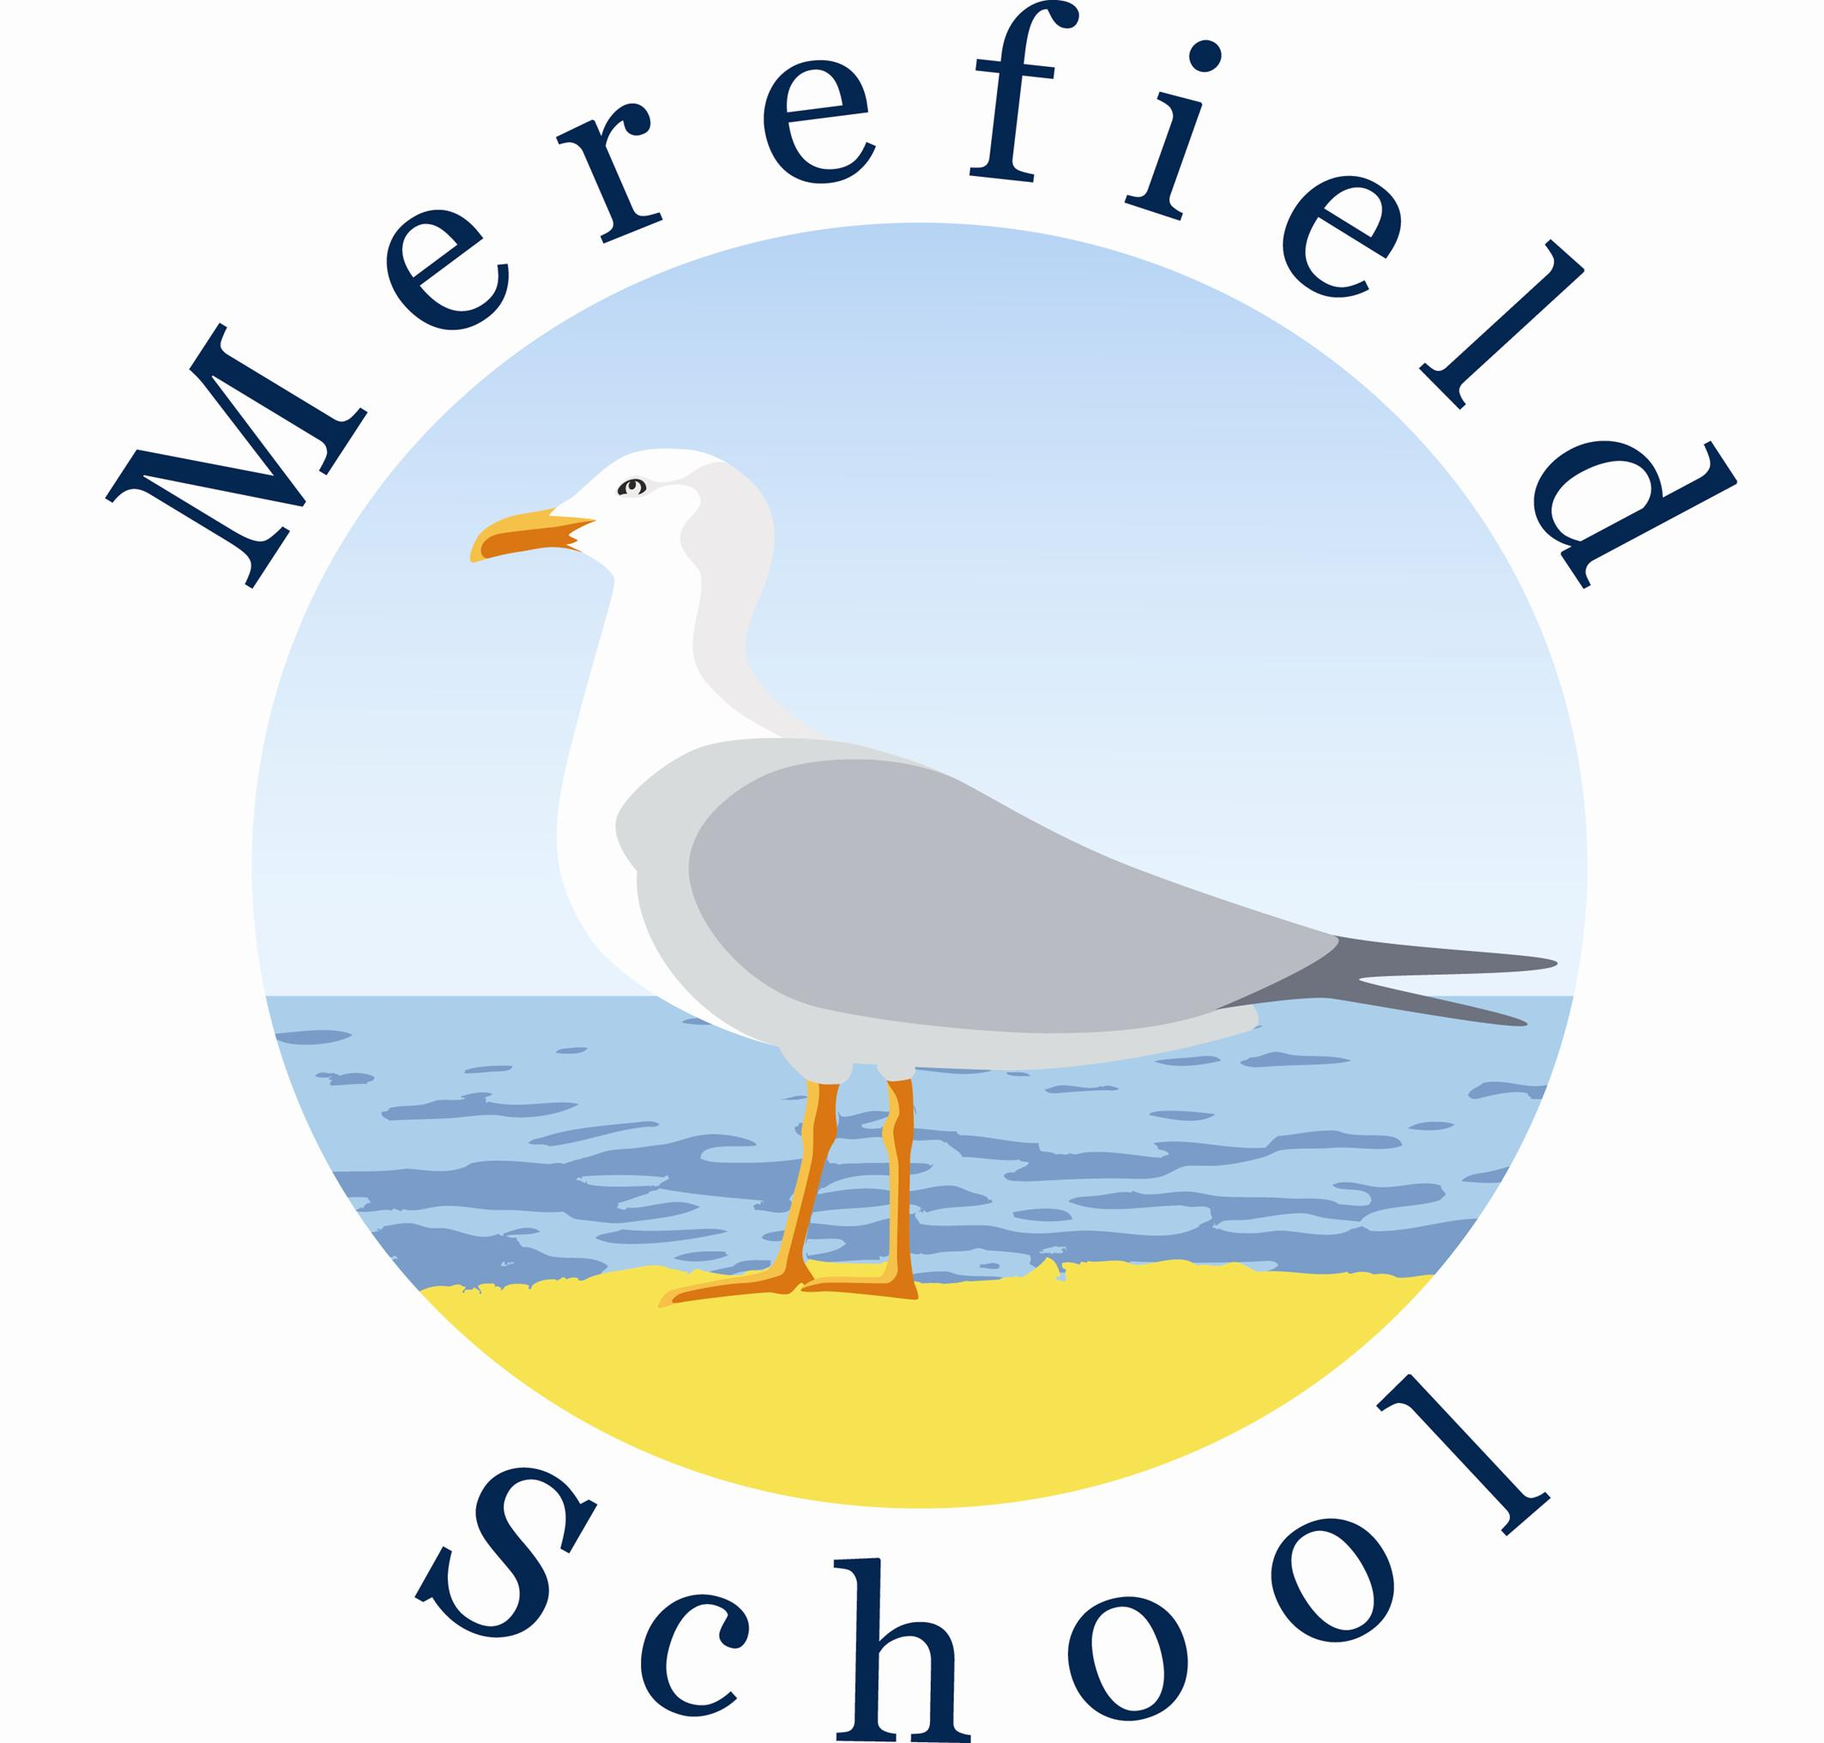
Merefield School
Post Title: | Teaching Assistant  Permanent
Hours: | 32.5 Hours per week, term time only
Grade:  Job evaluation No. | Band F SCP 12 - 19  A3385
Accountable to: | Headteacher and the Governing Body
Line Manager: | Deputy Headteacher

Job Description Teaching Assistant.

Merefield School is committed to safeguarding and promoting the welfare of children and young people and expects all staff and volunteers to share this commitment.
This role is classified as ‘Regulated Activity’. It is a criminal offence to apply for this role if you are barred from working with children or adults. This post is exempt from the provisions of the Rehabilitation of Offenders Act 1974 and relevant care/safeguarding legislation and appointment will only be confirmed if a satisfactory Enhanced Disclosure is obtained from the Disclosure & Barring Service (DBS). A Barred List Check will be carried out prior to any offer of employment being made.
Job Purpose | To work with and supervise individuals and groups of children and young people with significant Special Educational Needs under the direction / instruction of teaching and / or senior staff, inclusive of specific individual learning needs, enabling access to learning for all pupils and assistance and support in classroom management and behaviour techniques. With specific responsibility to support the teaching and learning of children with severe and complex learning difficulties.
MAIN DUTIES
Teaching Assistant | Support for the Pupil  - Establish good working relationships with pupils, acting as a role model  - Be aware of and respond appropriately to individual pupil needs ensuring effective interaction  - Provide specific support to pupils dependent upon their individual needs ensuring their safety whilst supporting access to learning activities.  - Promote inclusion and acceptance of all pupils.  - Encourage pupils to interact with others and engage in activities led by the teacher.  - Promote self-esteem and independence.  - Provide feedback to pupils in relation to progress and achievement under the guidance and direction of the teacher.  - Provide additional support for individual pupils enabling them to maintain their access to learning, this will include personal care, pastoral support, and using specialist equipment to support pupil’s mobility.  - Pastoral Care – follow individual personal care plan, which includes toileting, dressing/undressing, washing, teeth cleaning and any other individual pupil/students’ needs.  - Pastoral Support – to support individual behaviour plans, social, emotional, wellbeing programs and any other pupil/students’ needs including supporting pupils with challenging behaviour.  - Specialist Equipment – to use specialist equipment to support pupil’s mobility/therapy such as standing frames, side lyers, walkers, hoists and any other individual pupil/students’ needs.  - Assisted Feeding – to provide support for students/pupils in their eating and drinking plans using specialist equipment such as Peg feeding, pump feeding and any other specialist equipment needed to support individual students/pupils.  - Medical Needs – willingness to support student/pupils individual medical needs providing such support as suctioning, administering emergency rescue medication, following appropriate training, and any other specific individual requirements.  Support for the Teacher  - Provide minimal clerical / administration support (e.g. photocopying, typing, filing, collecting money, etc.)  - Contribute to the creation of specialist resources e.g. visual supports for individuals / groups of pupils, which meet the needs of the pupils  - Assist with the display of children’s work.  - Create and maintain a purposeful, orderly and supportive environment, in accordance with lesson plans.  - In liaison with the teacher, utilise strategies to support pupils in achieving learning goals.  - Report pupil achievements, progress and issues as appropriate in agreed format.  - Undertake pupil record keeping as requested.  - Administer routine primary tests and invigilate exams.  - Promote good pupil behaviour, dealing promptly with conflict and incidents and encouraging pupils to take responsibility for their own behaviour in line with established school policy.  - Establish constructive relationships with parents / carers.  Support for the Curriculum  - Undertake structured and agreed learning activities / learning programmes, taking into consideration pupil learning styles.  - Undertake literacy / numeracy/accreditation programmes, recording achievements and progress and providing appropriate reports and feedback for the teacher.  - Support the use of ICT in learning activities and develop pupil’s competence and independence in its use.  - Prepare, maintain and use equipment / resources required to meet the lesson plans / relevant learning activity and assist pupils in their use.  - To act as a pool watch person during swimming sessions in the hydro pool and undertake all necessary training i.e. NRA Certificate  Support for the School  - Be aware of and comply with school policies and procedures relating to child protection, health, safety and security, confidentiality and data protection. Report all concerns to the appropriate person (as named in the policy concerned).  - Be aware of and support differences and ensure all pupils have equal access to opportunities to learn and develop.  - Contribute to the school ethos, aims and development / improvement plan.  - Appreciate and support the role of other professionals.  - Attend relevant meetings as required.  - Participate in training and other learning activities as required.  - To lead on clubs/activities within working hours to enhance the learning experience of the students/pupils as directed by Headteacher.  - Accompany teaching staff and pupils on visits, trips and out of school activities as required.  - Supporting pupils on an individual basis as required at out of school activities i.e. work experience, college links and other off-site activities
The post holder may reasonably be expected to undertake other duties commensurate with the level of responsibility that may be allocated.

Name:

Signed: Date:

Merefield School
Person Specification: Teaching Assistant

 | Essential | Desirable
Skills | - Ability to work effectively within a team environment, understanding classroom roles and responsibilities  - Ability to build effective working relationships with all pupils and colleagues  - Ability to promote a positive ethos and role model positive attributes  - Good personal numeracy and literacy skills
Knowledge and understanding | - General understanding of national curriculum and other basic learning programmes/techniques (within SEN sector, working with young people who have significant Special Educational Needs.)  - General awareness of inclusion, especially within a school setting  - Effective use of ICT to support learning | - Experience of resources preparation to support learning programmes  - Understanding of other basic technology – IPads, Laptops, computer programmes, photocopier
Qualifications and training | - Minimum 2 years experience of working with and/or caring for children within specified age range/subject area or NVQ II or equivalent in teaching assistance  - Requirement to complete DfES Teacher Assistant Induction Programme  - Willingness to participate in relevant training and development opportunities  - GCSE grade C/OLEVEL/L2 qualification in Maths and English  - Willingness to support pupils during swimming sessions  - Displays commitment to the protection and safeguarding of children and young people. Has up to date knowledge of relevant legislation and guidance in relation to working with, and the protection of, children and young people. | - Training in special educational needs strategies  - Willingness to undertake appointed person certificate in first aid administration
Professional values and practice | Must be able to demonstrate the following:  - High expectations of all pupils; respect for their social, cultural, linguistic, religious and ethnic backgrounds; and commitment to raising their educational achievements  - Ability to build and maintain successful relationships with pupils, treat them consistently, with respect and consideration, and demonstrate concern for their development as learners  - Demonstrate and promote the positive value, attitudes and behaviour they expect from the pupils with whom they work  - Ability to work collaboratively with colleagues, and carry out role effectively, knowing when to seek help and advice  - Able to liaise sensitively and effectively with parents and carers, recognising role in pupils learning  - Able to improve their own practice through observations, evaluation and discussion with colleagues
Behaviour Management | - Manage pupils behaviour effectively, using approaches which are appropriate to pupils’ needs in order to involve and motivate them.  - Maintain good relationships with pupils, exercise appropriate authority, and act decisively when necessary.
Assessment and Progress | - An understanding of assessment for learning  - Ability to motivate, engage and enthuse learners
Personal and professional qualities | - To comply with school routines and protocols as written and intended.  - To communicate effectively and willingly with all School stakeholders.  - To demonstrate awareness of the need to promote and protect the school’s profile and reputation  - Commitment to continuous professional development
Signed (Teaching Assistant): Date:
Signed (Headteacher): Date:
Review Date:

