SEFTON METROPOLITAN BOROUGH COUNCIL

JOB DESCRIPTION

SECTION: Sefton Public Health LOCATION: Sefton MBC

DIVISION: Health and Wellbeing POST NO:

JOB TITLE: Business Support Officer

GRADE: Indicative F JE NO:

Responsible To: Senior Manager within the Public Health Team

JOB PURPOSE

To support the Public Health with a wide variety of administrative tasks, with specific skills in minute taking, record keeping and meeting administration. This role will work flexibly across a team under the direction of the Business Manager, providing practical and organisational support to deliver public health programmes and campaigns, including collating, managing, and distributing relevant resources and materials.

MAIN DUTIES

- Undertake all associated administration duties relating to Public Health meetings including minute taking, calendar organisation and the production of an action tracker for key meetings.

- Undertake clerical tasks, e.g., answering the phone, information or requests from the Public Health Team, photocopying, electronic filing, emailing, shredding and archiving as well as providing practical and organisational support for programmes and campaigns.

- To provide support in facilitating meetings, assisting with the organisation of room bookings, the distribution of agendas/records of meetings and, where appropriate, taking notes where directed.

- Support the organisation of relevant conferences, seminars, workshops and events, ensuring that appropriate arrangements and bookings are made and that all costs are met within budget.

- Input/enter or update data into Council systems as directed, maintaining database records and having due regard to accuracy, confidentiality and data protection.

- To organise the collation and set up of folders and filing of reports, files, registers, and any other appropriate records in relation to the work of the Public Health team. Undertake appropriate administrative, clerical, and financial procedures to include use of Agresso.

- Co-ordination of Public Health Team responses to Freedom of Information requests.

- Support the co-ordination of client surveys, public engagement, co-production work, consultation and communication. Prepare and distribute questionnaires and/or marketing materials, collate responses, input data and support the analysis and reporting of information to inform decisions.

- To undertake any other duties appropriate to the work and grade of the post, as may be directed from time to time to meet the exigencies of the service.

- To process incoming and outgoing mail, secure mail & telephone handling.

- Liaise and collaborate with other council departments who provide services to public health e.g. intelligence, commissioning, procurement etc.

- To ensure that client information data is lawfully gathered, accurate and up-to-date and only divulged in accordance with the Data Protection Act 1998 and the local government common law duty of confidentiality. Failure to apply these duties can lead to the individual or the Department facing court proceedings.

ORGANISATION CHART

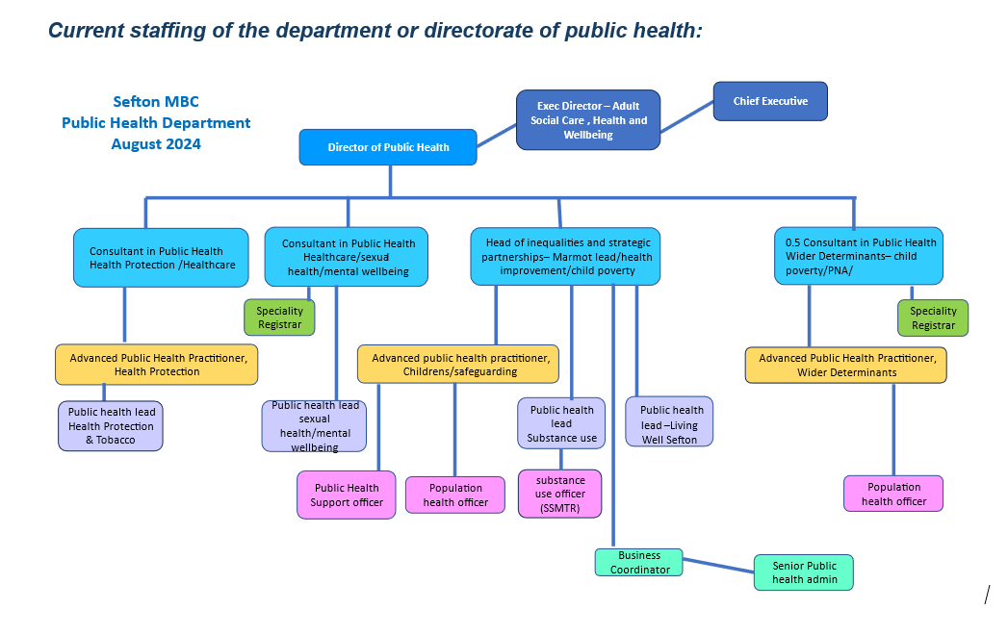
GENERAL

This job description is a representative document. Other reasonably similar duties may be allocated from time to time commensurate with the general character of the post and its grading.

All staff have a duty to take care of their own health & safety and that of others who may be affected by your actions at work. Staff must co-operate with employers and co-workers to help everyone meet their legal requirements.

The Authority has an approved equality policy in employment and copies are freely available to all employees. The post holder will be expected to comply, observe, and promote the equality policies of the Council.

Note: Where the postholder is disabled, every effort will be made to support all necessary aids, adaptations, or equipment to allow them to carry out all the duties of the job.

Since confidential information is involved with the duties of this post, the postholder will be required to exercise discretion at all times and to observe relevant codes of practice and legislation in relation to data protection and personal information.

Undertake, and participate in training, coaching and development activities, as appropriate and ensure all mandatory training is completed annually, or by the correct date.

The person appointed will be expected to work flexibly and the exact nature of the duties described above is subject to periodic review and is liable to change.

All staff are responsible for the implementation of the Health & Safety Policy as far as it affects them, colleagues and others who may be affected by their work. The postholder is also expected to monitor the effectiveness of the health and safety arrangements and systems to ensure appropriate improvements are made where necessary.

Occasional out-of-hours work may be required.

Due to the nature of the work involved, this post is “exempt” from the provision of the Rehabilitation of Offenders Act 1974 by virtue of the ROA 1974 (Exceptions) (Amendment) Order 1986.

Prepared by:

Name Anna Nygaard
Designation Head of Inequalities and Strategic Partnerships
Date April 2025

PERSON SPECIFICATION

Post: Business Assistant Post No:

Department: Public Health Division: Health & Wellbeing

Personal Attributes Required  (considerations) |  | Essential (E) or  Desirable (D) | Method of Assessment  (suggested)
QUALIFICATIONS/TRAINING  Level 3 Numeracy and Literacy or relevant professional experience  Level 2 Business and Administration qualification or relevant professional  ECDL and or relevant professional experience  GCSE English and Maths (grades A-C) or equivalent NVQ qualifications |  | E  E  E  E | AF  C  AF  AF
EXPERIENCE  Administrative procedures in Local government or similar environment.  Performing administrative tasks.  Processing requisitions and invoices.  Dealing/working with partners, officers, elected members and the public, on a regular basis.  Using a range of IT systems including MS Office, financial systems and other record keeping and data collection systems.  Organising, facilitating and supporting meetings and other events.  Supporting commissioning, contracting and procurement processes.  Supporting consultation and public engagement processes. |  | E  E  E  D  E  E  D  D | AF/I  AF/I  AF/I  AF/I  AF/I  AF/I  AF/I  AF/I
 | KNOWLEDGE / SKILLS / ABILITIES  Strong organisational skills, able to work in a pressurised environment and the ability to multi-task, use initiative and organise workloads to meet deadlines.  Excellent interpersonal skills and the ability to establish and develop links and contacts with a variety of groups, organisations and people at all levels.  Ability to work effectively, flexibly and constructively with colleagues in a team where team members work positively to a shared goal.  Ability to communicate effectively both verbally and in writing.  Proven ability to ensure a high standard of customer care is embedded within all work.  Financial skills in relation to budget work and financial procedures.  Recognises the importance to the Council of partnership working and embraces this where relevant to deliver services most effectively and efficiently.  Awareness and understanding of the need to establish and maintain accurate and effective information, record keeping and data collection systems  Knowledge and understanding of commissioning and contracting processes and practices. | E  E  E  E  E  E  D  D  D | AF/I/P  AF/I  AF/I  AF/I  AF/I  AF/I  AF/I  AF/I  AF/I
 | PERSONAL STYLE AND BEHAVIOUR  A team worker who works well in multi-disciplinary teams.  An understanding and commitment to equal opportunities.  A commitment to continuous improvement.  Commitment to continually develop and update knowledge.  Self motivating, reliable and flexible.  Respects confidentiality. | E  E  E  E  E  E | AF/I  AF/I  AF/I  AF/I  AF/I  AF/I

Assessment Methods Key:
AF – Application Form C – Certificates I – Interview

