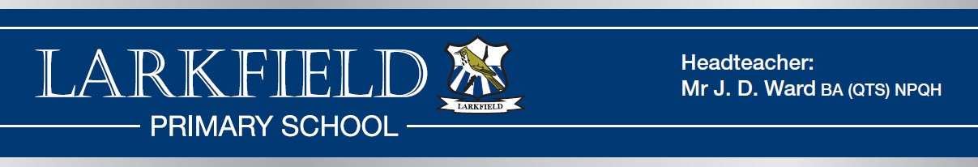

JOB DESCRIPTION – CLASS TEACHER MAIN SCALE
The responsibilities of the post are to be performed in accordance with the provisions of the most up to date edition of the School Teachers’ Pay and Conditions document and within the range of teachers’ duties set out in that document.

Job Purpose
To carry out professional duties and to have responsibility for an assigned class.
To be responsible for the day-to-day work and management of the class and the safety and welfare of the pupils, during on-site and off-site activities.
To promote the aims and objectives of the school and maintain its philosophy of education.

Main duties and responsibilities
- To create and manage a caring, supportive, purposeful and stimulating environment which is conducive to children’s learning.
- To plan and prepare lessons in order to deliver the School Curriculum ensuring breadth and balance in all subjects in accordance with school policy.
- To identify clear teaching objectives and learning outcomes, with appropriate challenge and high expectations.
- To maintain good order and discipline among the pupils, safeguarding their health and safety.
- To organise and manage groups or individual pupils ensuring differentiation of learning needs, reflecting all abilities.
- To plan opportunities to develop the social, emotional, spiritual, moral and cultural aspects of pupils’ learning.
- To ensure children’s work is marked regularly and appropriate feedback given in line with school policy.
- To maintain a regular system of monitoring, assessment, record-keeping and reporting of children’s progress in accordance with school policy
- To prepare appropriate records for the transfer of pupils.
- To ensure effective use of support staff within the classroom, including parent helpers.
- To participate in staff meetings as required.
- Contribute to the development and co-ordination of a particular area of the curriculum.
- To be part of a whole school team, actively involved in decision-making on the preparation and development of policies and programmes of study, teaching materials, resources, methods of teaching and pastoral arrangements.
- To ensure that school policies are reflected in daily practice.
- To communicate and consult with parents over all aspects of their children’s education – academic, social and emotional.
- To liaise with outside agencies when appropriate eg. Educational Psychologist.
- To continue professional development, maintaining a portfolio of training undertaken.
- To meet with parents and appropriate agencies, to contribute positively to the education of the children concerned.
- To support the Headteacher in promoting the ethos of the school.

- To promote the welfare of children and to support the school in safeguarding children though relevant policies and procedures.
- To promote equality as an integral part of the role and to treat everyone with fairness and dignity.
- To recognise health and safety is a responsibility of every employee, to take reasonable care of self and others and to comply with the Schools Health and Safety policy and any school-specific procedures / rules that apply to this role.

An annual review of this job description and allocation of particular responsibilities will take place as part of the Performance Management Review. In order to progress up the pay scale teachers will need to be able to evidence developing skills against the relevant career stage expectations as defined by the school performance appraisal system.

PERSON SPECIFICATION – CLASS TEACHER MAIN SCALE

 | Desirable (D) / Essential (E) | Application (A) / Interview (I)/ Observation (O)/  Reference (R)
Qualifications
Degree or equivalent | D | A
Qualified Teacher Status | E | A
Recent and relevant professional development | D | A/I
Professional knowledge and Experience
Clear philosophy of education and an awareness of  current educational issues and initiatives | E | A/ I/R
Excellent classroom practitioner, with a secure  knowledge of good practice in planning, differentiation and assessment. | E | A/I/O/R
Ability to provide the highest quality learning  environment | E | A/I/O/R
Ability to identify and meet the needs of all learners to  ensure high levels of progress and attainment | E | A/I/O/R
Experience of teaching the relevant age range | D | A/I
Professional Skills
Ability to work effectively as part of a team | E | A/I/R
Ability to work positively and sensitively with children,  parents and our other partners | E | A/I/R
Confident in using ICT to enhance and support teaching  and learning | D | A/I/O/R
Positive behaviour management strategies | E | A/I/O/R
Commitment to high expectations for all children | E | A/I/O/R
Commitment to safeguarding and promoting the welfare  of all children | E | A/I/R
Personal skills and attributes
Good organisational and interpersonal skills with the  ability to communicate effectively. | E | A/I/O/R
Enthusiastic, flexible and self motivated. | E | A/I/O/R
Willingness to become involved in extra curricular  activities and the wider life of the school | D | A/I/R
To demonstrate a commitment to equality, diversity and  inclusion within the school. | E | A/I/R
Commitment to further professional development. | E | A/I/R

