
Deputy SENCo & Lead Teacher
(SEND Provision)
Dear Applicant,
Thank you for your interest in the position of Deputy SENCo/Lead Teacher at Linaker Primary School.

The Endeavour Learning Trust board and I are delighted to provide the enclosed information about the role and our School. I hope you find it helpful and on behalf of the whole school community, I would like to take this opportunity to extend a very warm welcome.

Endeavour Learning Trust is a growing Trust in the North West. In our family of schools at this point in our growth, we have four secondary schools and six primary schools formally within the Trust.

Our mission and values provide a clear framework for us to work to. We are absolutely committed to serving our communities to ensure that every child achieves their potential by providing the highest quality educational experience in a truly inclusive way.

As a Trust, we don’t believe in a one-size-fits-all approach for our schools or our students. We respect and celebrate individuality, working with a clear determination to support our children, colleagues and communities both collectively, and individually, to flourish and thrive through a rich and transformational provision.

We believe in the value of collaboration, and everybody working with the Trust shares a collective responsibility for the success of all of our children. We also recognise that we will never be successful in delivering our vision for our young people unless our colleagues are supported, nurtured and developed to achieve their full potential with us. That’s why we are equally committed to ensuring every colleague benefits from the best possible employment experience where high-quality CPD and a sincere approach to supporting wellbeing enable our colleagues to achieve their own aspirations for their career.

We hope the enclosed information will give you good insight into our School & Trust.

We look forward to viewing your application.

Yours faithfully,
David Clayton
Chief Executive

Endeavour Learning Trust’s Mission and Values
We will serve our communities to ensure that every child realises their potential
We pledge that our schools will be transformational places of academic excellence that offer a true richness of experience, providing all children with the same opportunities to flourish and develop their unique skills, qualities and talents.
We will work collaboratively with our colleagues, parents and carers and our partners to remove any barriers that place limitations on our children, creating schools that are happy and harmonious places at the centre of their community.
Our Values
Individuality
We are firmly committed to recognising, celebrating and investing in the individuality of all of our children and young people, each of our colleagues and the distinct ethos and identity of each of our schools, whilst remaining united by our core values. We don’t believe in a “one size fits all” approach, and will adapt our provision to meet individual needs.
People centred
Our work is driven by our responsibility to every individual within our Trust community. Every person deserves to be treated with respect, dignity and kindness. We demonstrate empathy and humility in our approach, ensuring that our Trust provides an environment where every individual feels confident to be their true authentic self.
Belonging
Equity of opportunity is central to our practice and we will be relentless in our endeavour to identify and remove barriers that prevent full inclusion. Our culture extends beyond tolerance to one where difference is embraced and every individual is valued and celebrated for their unique contribution to our community. Every individual is a full member in our community.
Transformation
We believe in the promise of each individual across the Trust and will ensure we inspire, support and challenge in proportionate measure, so that we all thrive and are able to achieve our own individual successes. We are bold in our approach, stretching perceived boundaries, to go further for our children, colleagues and communities. We continually develop our approach to respond to changes in the communities we operate within to support every child, colleague and partners to realise their potential.
Togetherness
We are a proud family of schools bonded by our Trust vision, priorities and values. We work as one team in school, across our Trust and with our wider partners for the benefit of the communities we serve. Our collaborative approach inspires us to be bold and brings us together in ways that help us to make a difference. We are better together.

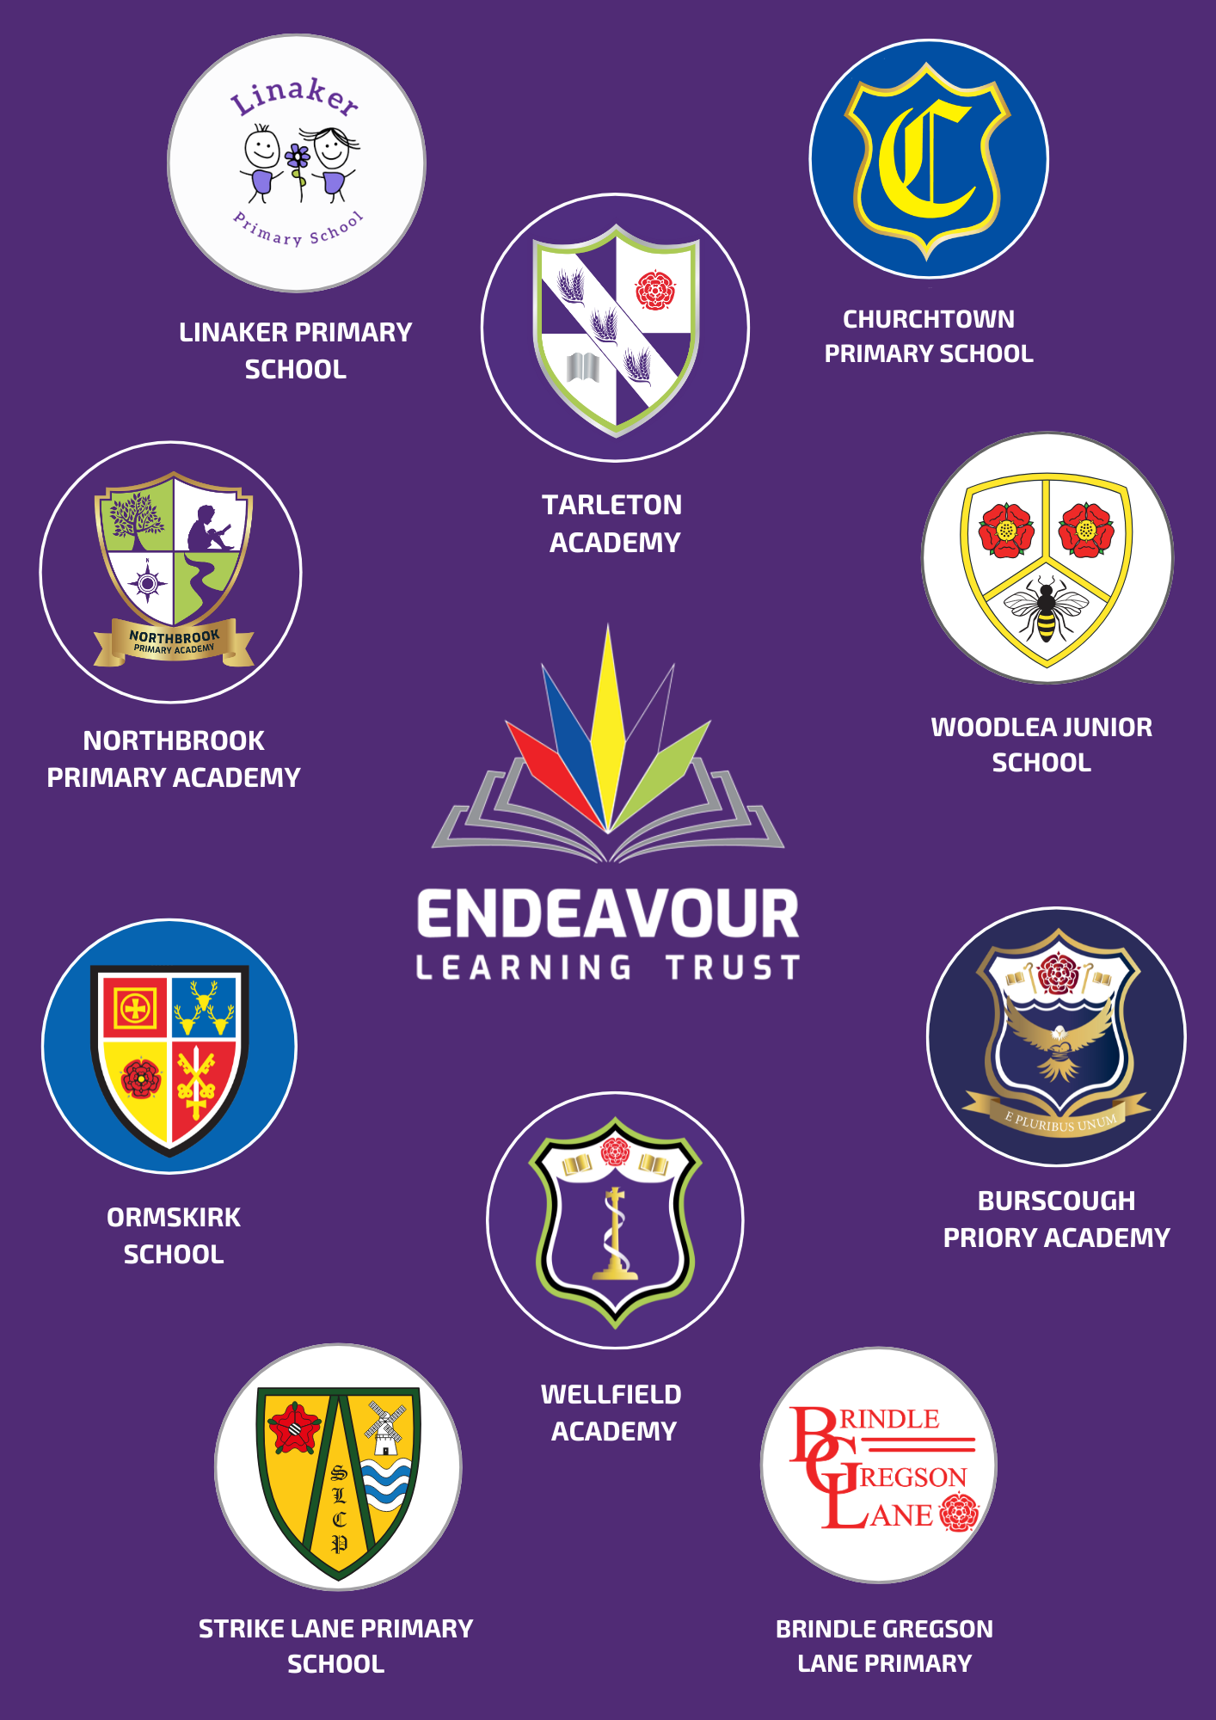
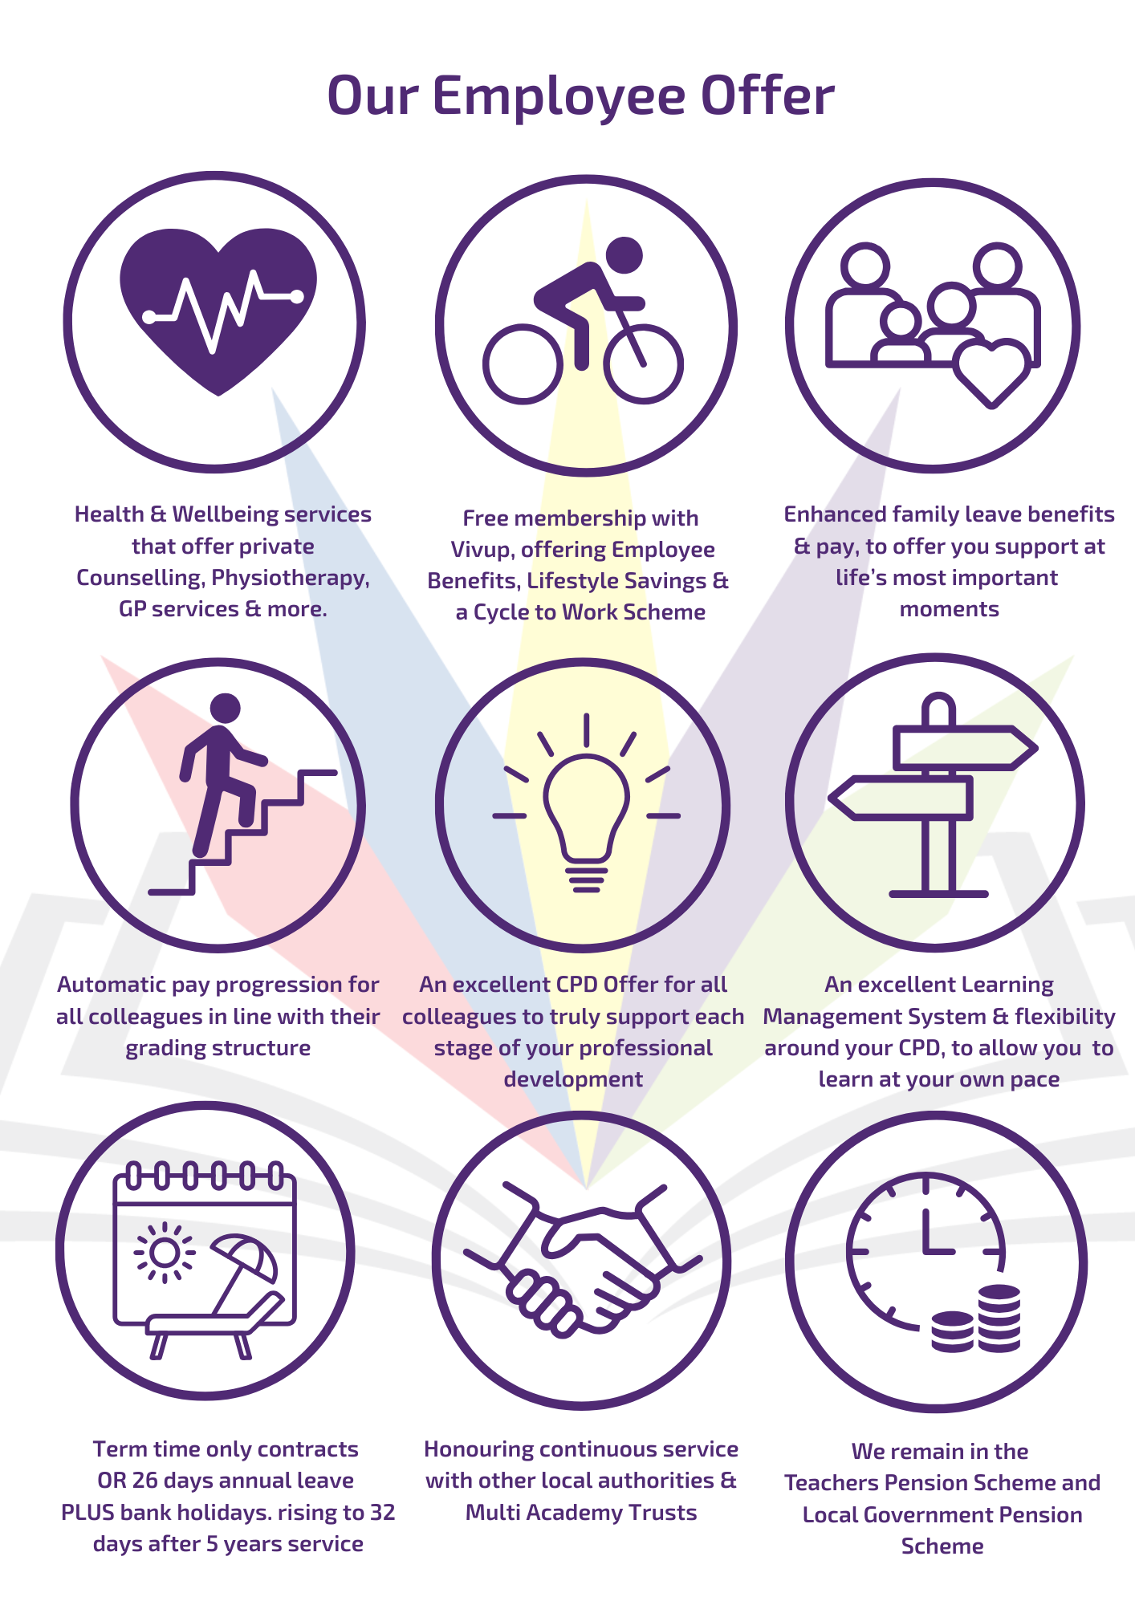
ENDEAVOUR LEARNING TRUST
OUR SCHOOLS

Dear Applicant,
Thank you for your interest in the position of Teaching Assistant at Linaker Primary School.
We are delighted to send you the enclosed information about our school.
Linaker Primary School is part of Endeavour Learning Trust and has thrived as part of a successful family of schools. Our children are hardworking, enthusiastic and keen to work with their teachers and support staff to get the very best out of each and every day at school.
Our school is a happy school; we work together for the good of the team and we are a team where everyone is valued as an individual. In our school we have high expectations but also a pragmatic emphasis on challenge and support. This counts for students and staff, teaching and non-teaching, everyone wants the best for everyone else.
In our team, our staff are committed to improving the experience of our children with a genuine desire to help them become the best person they can be. They are wholly optimistic and driven towards making the school the very best it can be. Underpinning all we do is a commitment to developing the children in our school to become kind, well rounded and confident learners. We want to develop young people who believe in, and have the skills, to realise their own worth and potential.
The Trustees and our Local Academy Council are extremely proud of the school’s journey and successes to date. We are committed to promoting an ethos and culture of high aspiration and celebration, whilst providing a friendly and inclusive environment underpinned by a pastoral care system that values every member of the school community.
If this sounds like the school for you, please read on!
Yours faithfully,
Mr M Cunniffe
Headteacher

Deputy SENCo & Lead Teacher (SEND Provision)
Full time, Permanent
MPR1-UPR3 plus TLR
£32,916 - £51,048

We are now looking to appoint a Deputy SENDCo/Lead Teacher within the SEND Provision, to join us in an exciting time in our School and Trust’s journey. We are looking for someone who gets who we are at Linaker Primary School, can inspire our school community, build on the excellent practice already in place and contribute to the Trust as a whole. Our SEND Shore Provision, opening in September 2026, will support children on the SEND register by ensuring they work from their current individual needs. Access to the provision will be based on need rather than age, enabling children to benefit from a fully bespoke curriculum within a fully integrated setting.
As the new Deputy SENDCo/Lead Teacher within the SEND Provision you will:
- Be responsible for the leadership and management of the provision within the school to provide effective provision whilst children are withdrawn from mainstream lessons.
- Design and deliver a bespoke curriculum tailored to the individual needs of the children accessing the provision, continually assessing and adapting their approach to ensure every child thrives and is fully supported as they move into the next phase of their educational journey.
- Provide high quality care, intervention and support to children to enable them to access education and achieve their full potential.
- Lead the Teaching Assistants on a daily basis.
- Provide support to children who demonstrate difficulties
- Liaise with other staff and external agencies, where appropriate, to re-engage children in learning within the provision and within mainstream lessons.
We are ideally looking for someone with experience of teaching in either a primary or specialist setting who has a real passion to work with and champion our SEND learners. This role will involve working strategically with senior leaders, especially the school’s SENDCo, to develop and evolve our provision and is therefore a fantastic opportunity for anyone looking for a first or next step into middle or senior leadership.
The successful candidate must have experience of working with children who have additional, special educational needs.
Whether you are a qualified SENDCo or a teacher who is looking to complete their SENDCo qualification, if you are committed to championing inclusion for all and looking for an opportunity to support with leading an exceptional provision within our school, we want to hear from you.
HOW TO APPLY
To apply, please complete an application form in full, along with a personal statement to support your application, outlining the relevant experience you can bring to Endeavour Learning Trust.
Applications should be submitted by 9am on Friday 15th May. Lesson observations within the applicant’s own school will be arranged.
Interviews are to be held on Wednesday 20th May.
If you require any further information about this role, please contact our Operations Manager, Lana via l.smailiukaite@linaker.org.uk
SAFEGUARDING
Endeavour Learning Trust is committed to safeguarding and promoting the welfare of children, young people and vulnerable adults and expects all staff and volunteers to share this commitment and individually take responsibility for doing so.
Please note that in line with Keeping Children Safe in Education, an online search will be carried out as part of our due diligence on shortlisted candidates.

Job Description
Job Title: | Deputy SENDCo/Lead Teacher within the SEND Provision
Reports to: | Assistant Head - SEND & Inclusion
Based at: | Linaker Primary School
Grade: | MPR1-UPR3 with TLR
Main purpose of the role
The Deputy SENDCo will work directly with the Assistant Head for SEND & Inclusion across the school
The successful candidate will need to provide our children within the SEND provision with an outstanding education and provide strong and effective leadership of the provision. The role will have many SEND, Inclusion and whole school responsibilities attached.

This will include:
- Teaching within and the leadership & management of the school’s SEND provision, to provide effective provision whilst children are withdrawn from mainstream lessons.
- Manage the team of staff including learning support assistants and other staff to ensure AP students’ needs are met; this includes external providers. This includes line management of the learning support assistants based in the AP.
- Work closely with teachers across all phases to ensure a clear, shared understanding of each child’s needs. Through strong communication and collaboration, you will help secure seamless support and consistent next steps as part of our whole‑school provision.
- Plan the provision’s timetable and sessions to support children’s academic and SEMH progress.
- Ensure all students in the provision have access to a bespoke curriculum supported by a creative approach which includes providing care, intervention and support to children to enable them to access education and achieve their full potential.
- Managing student data on systems (e.g., SIMS), maintaining SEND registers, and managing EHCP evidence, reviews, and applications.
- Leading the Teaching Assistants on a daily basis.
- Providing support to children who demonstrate difficulties with communication and interaction.
- Assisting the SENCo in the day-to-day operation of the SEND department, implementing policies, and ensuring high-quality teaching for SEND learners.
- Leading on the transition of SEND pupils between key stages or schools.
- Ensure the school meets its statutory requirements with regards to SEND provision and support/intervention identified within EHCPs.
- Implementing and monitoring the School’s Rewards & Relationship Guidance and promoting positive behaviour amongst all children.
- Provide intensive support to help address behaviour and/or social and emotional difficulties.
- Execute a cycle of ‘plan-do-review’ to monitor progress.
- Work in close conjunction with teachers, parents/carers and/or external agencies where appropriate to re-engage children in learning within the provision and within the children’s mainstream lessons.
Support for the Children
- Work with the SENDCO and any other staff with Special Educational Needs expertise, to ensure appropriate targets are set and work is well matched to children’s needs.
- Subjects and other relevant activities which support the wholistic development of the child
- Establish a partnership with parents/carers to involve them with all aspects of their child’s development: personal, social and academic whilst they are accessing the resource provision
- Liaise with the Attendance Officer in establishing constructive contact with the parents of children whose attendance and punctuality does not meet the standards expected
- Challenge and motivate children to promote and reinforce self-esteem.
- Use information provided by staff to discuss issues with children, reinforce expectations and put in place strategies to address.
- Instigate intervention and support programmes that make clear short, medium and long-term targets with review points planned in.
- Oversee re-integration, where appropriate, into mainstream classes and success through a RAG rated timetable and close monitoring through reports.
- Work with children to monitor the success of support strategies.
- Encouraging children to interact and work cooperatively with others and engage all children in activities. Promote independence and employing strategies to recognise and reward achievement.
- Assist with the development and implementation of individual Education/Behaviour Plans and Personal Care Programmes and external referrals if necessary.
- Establish constructive relationships with children and interact with them according to individual needs. Deliver group or individual interventions where necessary to support social, emotional and academic progress.
- Promote inclusion and acceptance of all children.
- Encourage children to interact with others and engage in activities led by the teacher.
- Set challenging and demanding expectations and promote self-esteem and independence.
- Ensuring that the school keeps the records of all children with SEND up to date.
- Liaising with other providers, outside agencies, educational psychologists and external agencies.
- Ensuring that the school keeps the records of all pupils with SEND up to date.
- Manage the effectiveness of provisions for children with SEND development needs.

Support for Teachers/Teaching Assistants
- Line-managing Teaching Assistants, including their performance management, scheduling, and training.
- Work with other staff in planning, evaluating and adjusting learning activities as appropriate.
- Monitor and evaluate children’ responses and progress against action plans through observation and planned recording.
- Provide objective and accurate feedback and reports as required, to other staff on student achievement, progress and other matters, ensuring the availability of appropriate evidence.
- Be responsible for keeping and updating records as agreed with other staff, contributing to reviews of systems/records as requested.
- Establish constructive relationships with parents/carers, exchanging information, facilitating their support for their child’s attendance, access and learning, and supporting home to school and community links.
- Assist in the development, implementation and monitoring of systems relating to attendance and integration.
- Clerical/admin support e.g. dealing with correspondence, compilation/analysis/reporting on attendance, exclusions etc. making phone calls etc.

Support for the School
- Be aware of and comply with policies and procedures relating to child protection, health, safety and security, confidentiality and data protection, reporting all concerns to an appropriate person.
- Be aware of and support difference and ensure all pupils have equal access to opportunities to learn and develop.
- Contribute to the overall ethos/work/aims of the schools.
- Establish constructive relationships and communicate with other agencies/professionals, in liaison with the teacher, to support achievement and progress of pupils.
- Attend and participate in regular meetings.
- Participate in training and other learning activities as required.
- Recognise own strengths and areas of expertise and use these to advise and support others.
- Assist in the supervision, training and development of staff.
- Promote the inclusion and acceptance of all children

Other
- The Trust is committed to safeguarding and promoting the welfare of children and young people and expects all staff and volunteers to share this commitment.
- To pursue and promote the achievement and integration of diversity and equality of opportunity throughout the Trust
- To plan, monitor and review health and safety within areas of personal control
- To participate in the Trust’s Professional Development Review process and engage in continuous professional development and networking to ensure that professional skills and knowledge are up to date.
- To maintain high professional standards of attendance, punctuality, appearance, conduct and positive, courteous relations with children, parents, and colleagues

PERSON SPECIFICATION
Qualifications and CPD | Essential | Desirable
Qualified Teacher Status | X
To already hold or to have a willingness to work towards National Professional Qualification-SEND | X
Experience, Knowledge and Skills | Essential | Desirable
Experience of working with children within the primary age range. | X
Experience of working with pupils with additional needs. | X
Very good Numeracy/literacy skills (equivalent to NVQ 2 in English and Maths). | X
Experience of conducting SEND review meetings. |  | X
Full working knowledge of relevant policies/codes of practice and awareness of relevant legislation. | X
Work constructively as part of a team, understanding classroom roles and responsibilities and your own position within these. | X
Working knowledge of national curriculum and other relevant learning programmes. | X
Understanding of principles of child development and learning processes and in particular, barriers to learning. | X
Ability to plan effective actions for pupils at risk of underachieving. | X
Full understanding of the range of support services/providers. |  | X
Personal Attributes | Essential | Desirable
Ability to relate well to children and adults. | X
Ability to self-evaluate learning needs and actively seek learning opportunities. | X
English Fluency
Possessing a relevant qualification for the role attained as part of education in the UK or full taught in English by a recognised institution abroad | X
Passing an English or Welsh spoken language competency test or possessing a relevant spoken English or Welsh qualification at CEFR Level B1 or above, taught in English by a recognised institution abroad. |  | X

